HOME PAGE

1. Slider is width is 20px bigger. Make it make it equal to all the columns. Slider should me 940px not 960px.

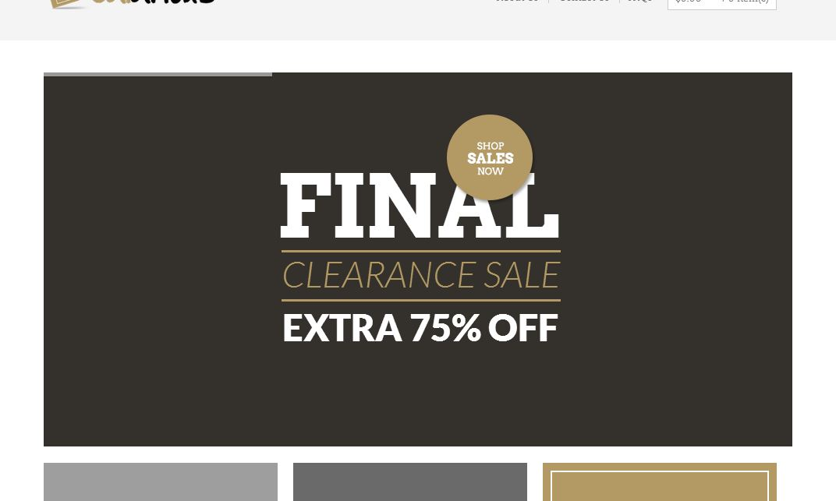

2. Footer goes left side. Make it center.



3. Product images goes outside of container and text got hidden.

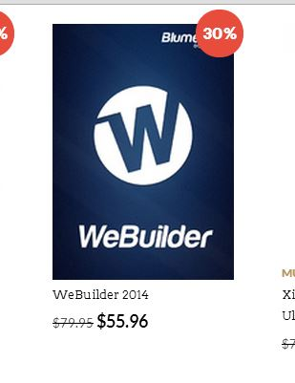

4. Add top padding 20px.Text should be center of the line.

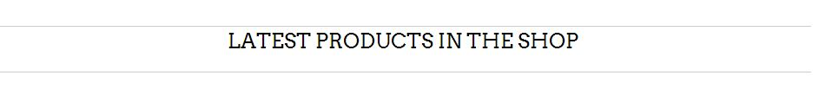

**Home page responsive**

**Tab portrait view (768px and 600px small tabs)**

1. Those two lines should be equal

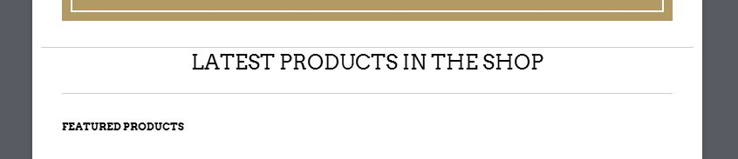

2. Make some space into small dash line and image may be 10-20px

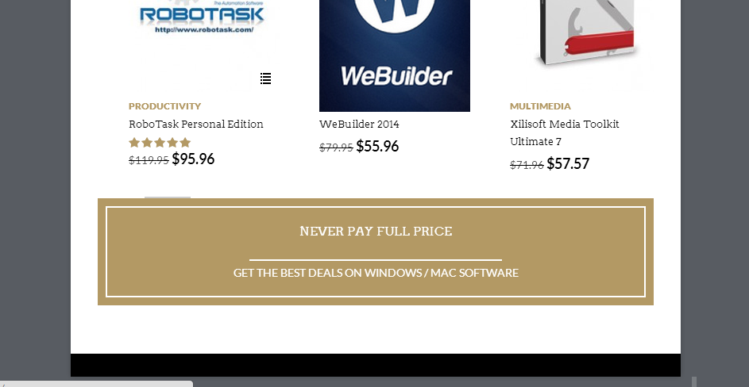

3. Image going outside of container



4. Footer is PayPal image and copy right text not aligned with the container



5. Make gap 10px top and 10px bottom



6. Track your order and search is falling down.(768px)

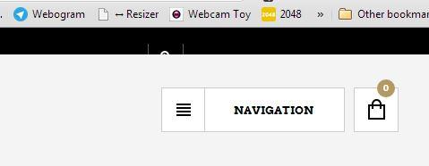

**Mobile view**

1. Make those navigation buttons smaller



2. Image going outside of container in footer



**Product page**

1. Remove the blue out line on click

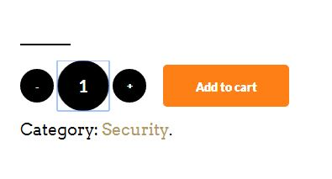

2. Related product add to cart button hove animation bug (same bug is also in category pages)

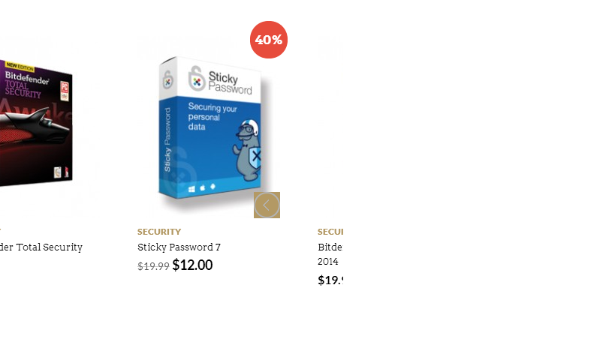

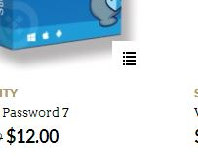

3. Add review stars bug

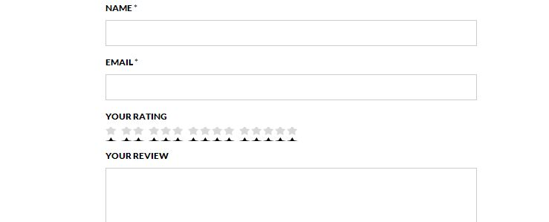

**Tab portrait view (768px and 600px small tabs)**

1. Make reseller image to center of the screen and contain height to auto

768

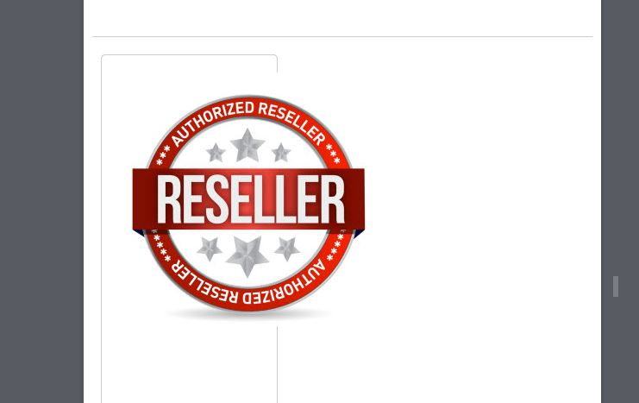

600

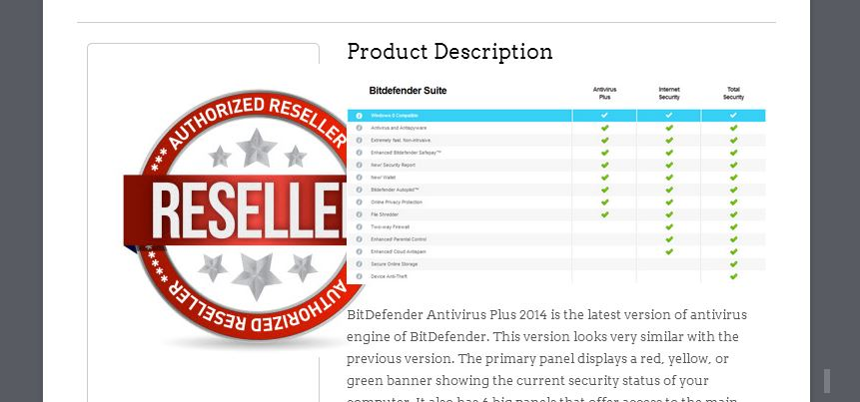

2. Align the comment area tab and make some padding in button so it can look like desktop

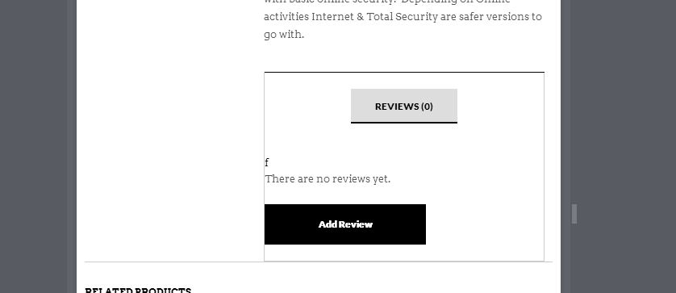

**Mobile view**

1. Make reseller image to center of the screen and contain height to auto

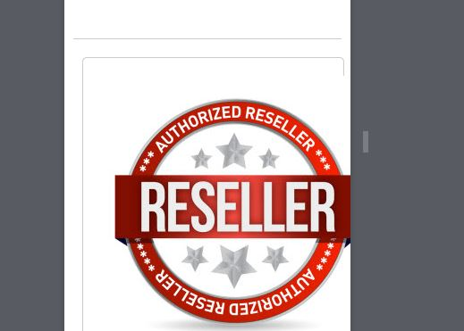

2. Align the comment area tab padding in button so it can look like desktop

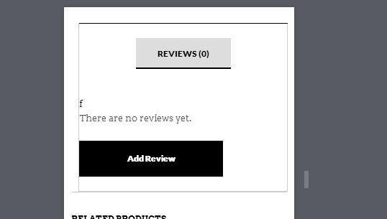

**Checkout page**

1. Make 10px gap between Name and Email input filed

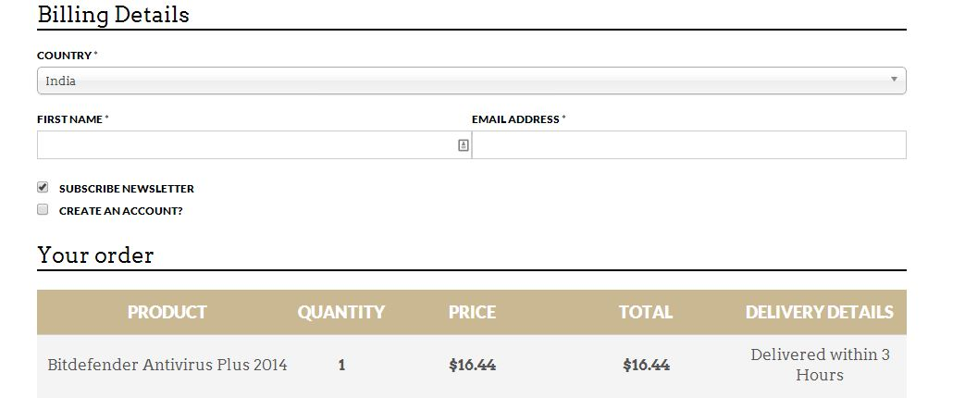

2. Make 10px gap between Username and password input field

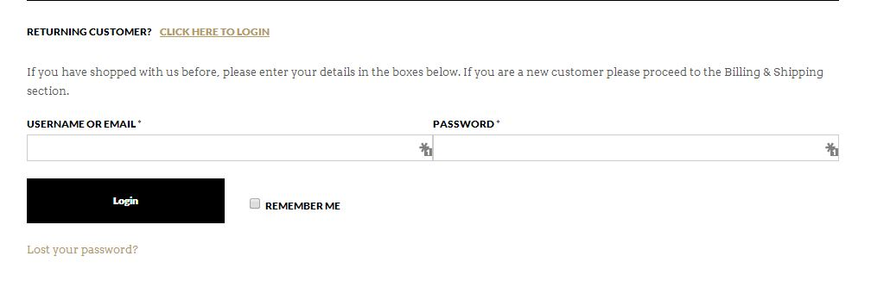

**Mobile view checkout page**

1. Product list table go outside of container make it like actual theme check out area in responsive and in desktop and mobile view don’t make Price and Total to be bold and In tab view make font size smaller.

